

Packet Tracer - Single-Area OSPFv2 Configuration

Name: Luis Enrique Perez Señalin.

# Addressing Table

|  |  |  |
| --- | --- | --- |
| **Device** | **Interface** | **IP Address / Prefix** |
| P2P-1 | S0/1/0 | 10.0.0.1/30 |
|  | S0/1/1 | 10.0.0.9/30 |
|  | S0/2/0 | 10.0.0.13/30 |
| P2P-2 | S0/1/0 | 10.0.0.2/30 |
|  | S0/1/1 | 10.0.0.5/30 |
|  | G0/0/0 | 192.168.1.1/24 |
|  | G0/0/1 | 192.168.2.1/24 |
| P2P-3 | S0/1/0 | 10.0.0.6/30 |
|  | S0/1/1 | 10.0.0.10/30 |
|  | G0/0/0 | 192.168.3.1/28 |
| BC-1 | S0/1/0 | 10.0.0.14/30 |
|  | S0/1/1 | 64.0.100.2/30 |
|  | G0/0/0 | 10.0.1.1/29 |
| BC-2 | G0/0/0 | 192.168.4.1/30 |
|  | G0/0/1 | 10.0.1.2/29 |
| BC-3 | G0/0/0 | 192.168.5.1/24 |
|  | G0/0/1 | 10.0.1.3/29 |
| Internet Server | NIC | 203.0.113.100/24 |
| PC 1 | NIC | 192.168.1.10/24 |
| Laptop 1 | NIC | 192.168.2.20/24 |
| Workgroup Server | NIC | 192.168.3.14/28 |
| PC 2 | NIC | 192.168.4.40/24 |
| PC 3 | NIC | 192.168.5.50/24 |

**Packet Tracer - Single-Area OSPFv2 Configuration**

# Objectives

Implement single-area OSPFv2 in both point-to-point and broadcast multiaccess networks.

# Background

You are helping a network engineer test an OSPF set up by building the network in the lab where you work. You have interconnected the devices and configured the interfaces and have connectivity within the local LANs. Your job is to complete the OSPF configuration according to the requirements left by the engineer.

Use the information provided and the list of requirements to configure the test network. When the task has been successfully completed, all hosts should be able to ping the internet server.

# Instructions

Configure the network to meet the requirements.

# Requirements

Use process ID 10 for OSPF activation on all routers.

* Activate OSPF using network statements and inverse masks on the routers in the Headquarters network.
* Activate OSPF by configuring the interfaces of the network devices in the Data Service network, where required.
* Configure router IDs on the multiaccess network routers as follows:

o BC-1: 6.6.6.6

o BC-2: 5.5.5.5

o BC-3: 4.4.4.4

* Configure OSPF so that routing updates are not sent into networks where they are not required.
* Configure router BC-1 with the highest OSPF interface priority so that it will always be the designated router of the multiaccess network.
* Configure a default route to the ISP cloud using the exit interface command argument.
* Automatically distribute the default route to all routers in the network.
* Configure the OSPF routers so that the Gigabit Ethernet interface cost will be 10 and the Fast Ethernet cost will be 100.
* Configure the OSPF cost value of P2P-1 interface Serial0/1/1 to 50.
* Configure the hello and dead timer values on the interfaces that connect P2P-1 and BC-1 to be twice the default values.

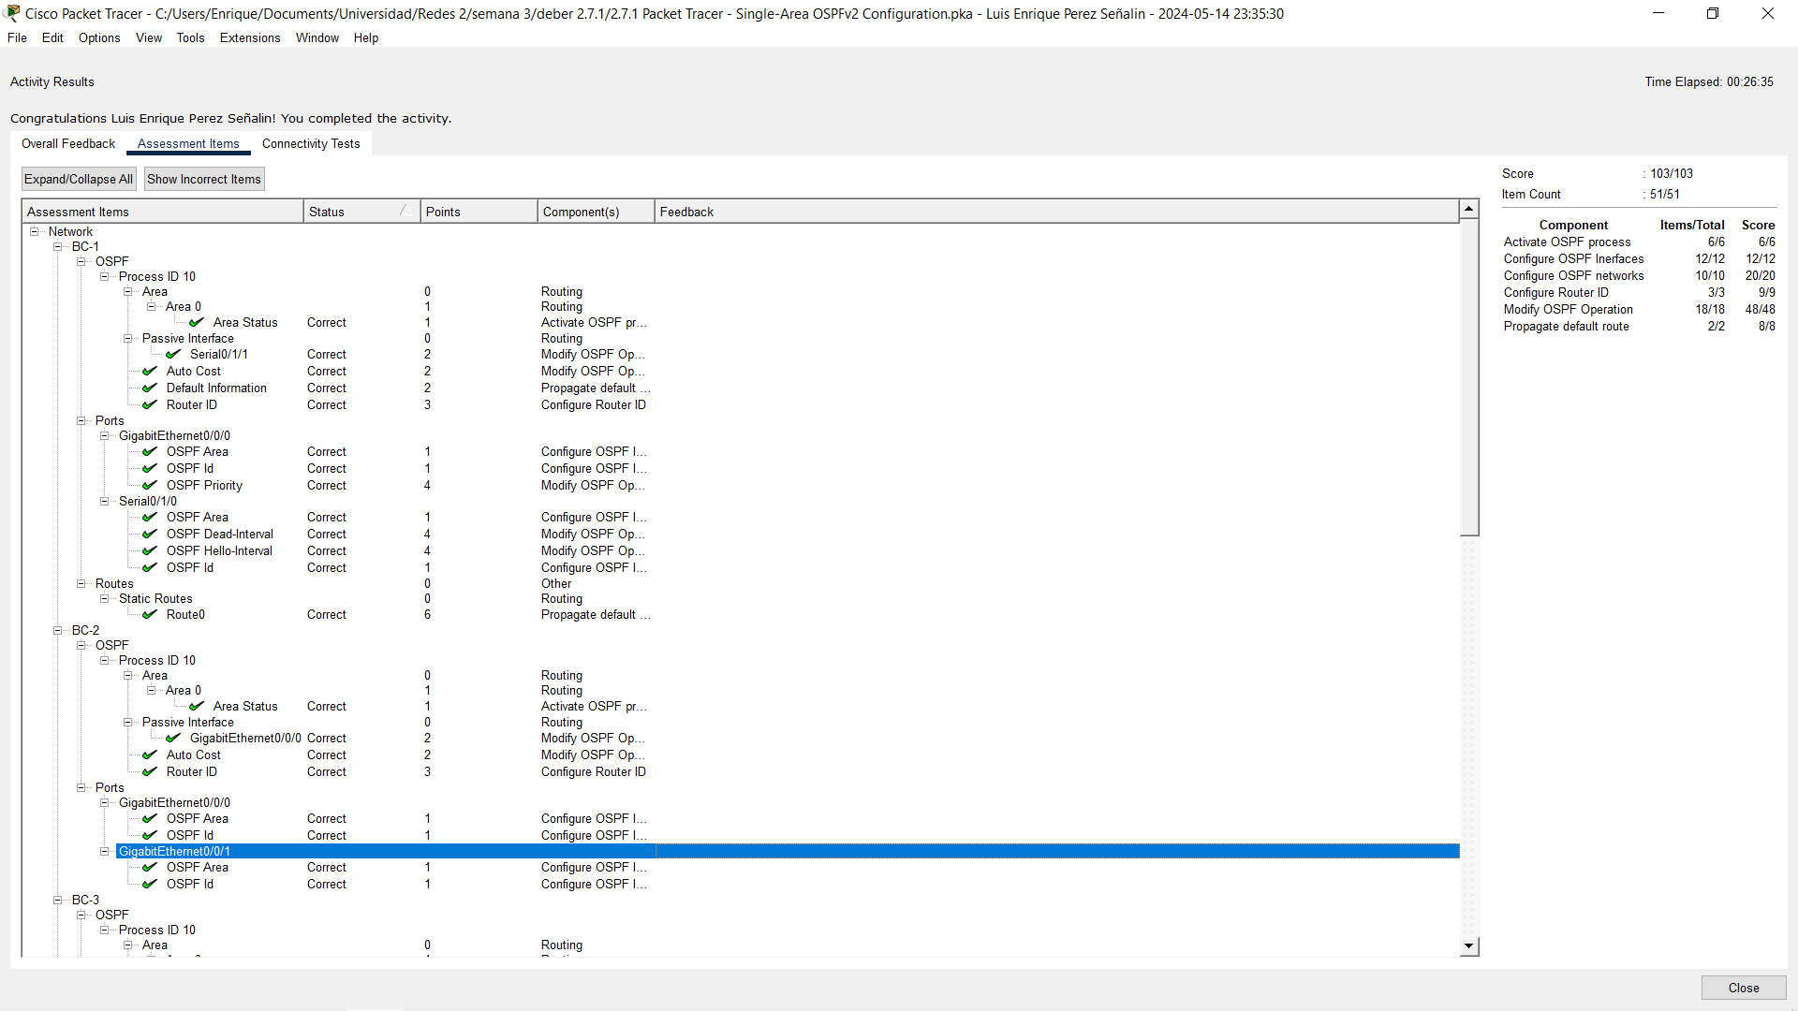**ScreenShot:**